**3. Lists and strings in python**

**3.1 Lists**

This is another useful link

<https://www.w3schools.com/python/python_lists.asp>

**3.2 Exercises**

1.What will the following code display?

numbers=[1,2,3,4,5]

numbers[2]=90

print(numbers)



2. What will the following code display

numbers= list(range(3))

print (numbers)



3. What will the following code display?

numbers = [10 ] * 5  
print(numbers)



4. What will the following code display? list command creates a list called numbers.

numbers=list(range(1,20,2))

for n in numbers:  
print(n)

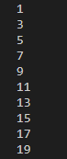

5. What will the following code display?

numbers= [1,2,3,4,5]  
print(numbers [-3])  


6. Write a code to find the number of elements in the list.

numbers = [1,2,3,4,5,'dog', 'cat']  
print(len(numbers))



7. What will the code display?

list1 = ["a", "b" , "c"]  
list2 = [1, 2, 3]  
list3 = list1 + list2  
print(list3)



8. What will the following code display?

num1= [1,2,3]  
num2=[100,200,300]  
num2+=num1  
print(num1)  
print(num2)



9. This program is used to print all the items in a list using the while command.

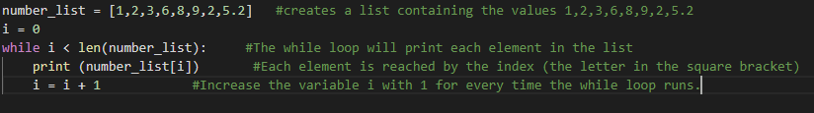

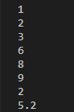

10. This program adds all the numbers in the list and finds the average

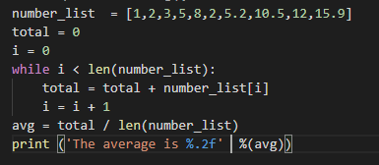



|  |  |
| --- | --- |
| **Method** | **Description ( Reference:** **https://www.w3schools.com/python/python_lists.asp)** |
| [append()](https://www.w3schools.com/python/ref_list_append.asp) | Adds an element at the end of the list |
| [clear()](https://www.w3schools.com/python/ref_list_clear.asp) | Removes all the elements from the list |
| [copy()](https://www.w3schools.com/python/ref_list_copy.asp) | Returns a copy of the list |
| [count()](https://www.w3schools.com/python/ref_list_count.asp) | Returns the number of elements with the specified value |
| [extend()](https://www.w3schools.com/python/ref_list_extend.asp) | Add the elements of a list (or any iterable), to the end of the current list |
| [index()](https://www.w3schools.com/python/ref_list_index.asp) | Returns the index of the first element with the specified value |
| [insert()](https://www.w3schools.com/python/ref_list_insert.asp) | Adds an element at the specified position |
| [pop()](https://www.w3schools.com/python/ref_list_pop.asp) | Removes the element at the specified position |
| [remove()](https://www.w3schools.com/python/ref_list_remove.asp) | Removes the item with the specified value |
| [reverse()](https://www.w3schools.com/python/ref_list_reverse.asp) | Reverses the order of the list |

**Exercise to illustrate built in functions of the list.**

thislist = ['apple', 'banana', 'cherry', 'pear']

thislist.remove('banana')

print(thislist)

thislist.append('orange')

print(thislist)

# insert item at the second position

thislist.insert(1,'blueberry')

print(thislist)

#Find the index of the item

index1=thislist.index('cherry')

print('The location of fruit cherry is at ', index1)

#This removes the item apple

thislist.remove('apple')

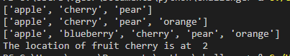

**Do this exercise yourself.**

Create a python program menu.py

1. Create a list *food* with the following items

[Pizza,Pancake,Chips,Burgers, Pasta]

1. Display the list
2. Ask the user which item you would like to change
3. Get the item’s index from the list ( use index option for list)
4. Replace the item with the new item.
5. Display the list.

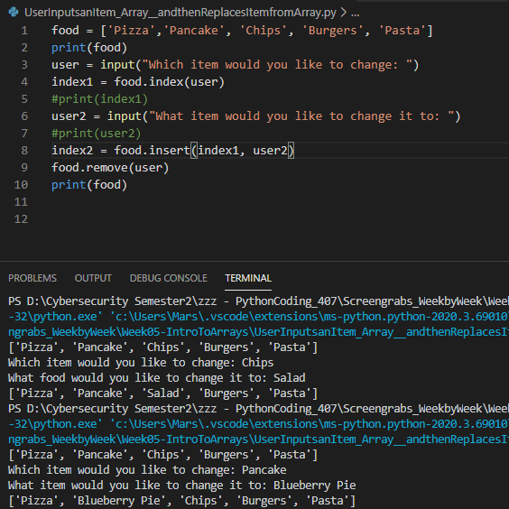

**3.3 Strings.**

**Refer to the link**

<https://www.w3schools.com/python/python_strings.asp>

Accessing the individual characters in a list.

You can use a for loop to iterate over a string with the for loop

**string1.py**

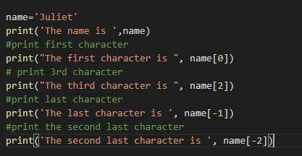

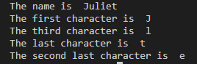

**3.3.1 String slicing**

This is used to select a range of characters from the string

To get a slice of a string, you write an expression in the general format

Eg.

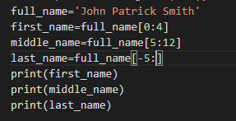



This shows the index no for each character.

**0 1 2 3 4 5 6 7 8 9 10 11 12 13 14 15 16 17**

**J o h n P a t r i c k S m i t h**

**-5 -4 -3 -2 -1**

[-5: ] from -5 to the end.

**3.3.2 Testing, searching and manipulating strings  
Test string with in and not in**

string1 in string2

string1 = ‘one two three four five ‘

if ‘ four’ in string1:

print(‘The string ‘four’ was found’)

else:

print(‘The string ‘four’ was not found’)

**output**

‘The string ‘four’ was found

**Exercise.**

Write a program that counts the number character in the sentence ‘The count of the character ‘c’ or ‘C’ in this sentence is needed’.

Modify this program to count the number of Cs or c’s

Hint: make the variable c_count

The output should be as follows



Strings are immutable. Once they are created, they cannot be changed.

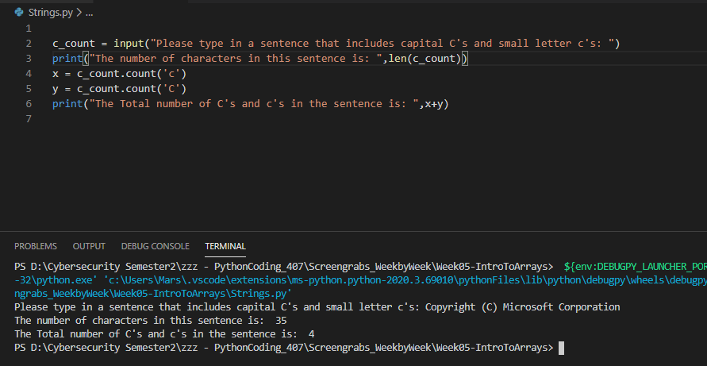

**3.3.3 String methods**

String testing

isalnum() checks whether string has only alphabets or digits

isalpha() checks if string has only alphabets

isdigit() checks if string has only digits.

islower() checks if letters are lower case

isupper() checks if letters are upper case

isspace() checks if string contains only whte space charcters

isupper() check if alphabetic letters are upper case

split() splits and makes a list with words in the string

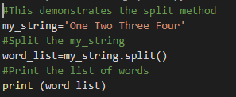



date_string = ‘11/12/2019’

date_list=date_string.split(‘/’)

The date string variable will have

[11,12,2019]

The data is split at the point where there is a ‘/’ and put into a list

**3.3.3 4 Exercise**

Simulate the rolling of a die with 6 sides. You have to import the random module

* import random
* Generate a number 1 to 6. Set *max_number* to 6 and *min_number* to 1.
* You can decide how many times you want to roll the dice
* Decide which of the numbers you want to add to a list *countarray*.
* Add **all the numbers rolled** and store it in variable *sum*.
* When the required number of rolling of dice are done, you have to print the list with the selected numbers.
* Print the total of all numbers generated.

